- Employee: Address:
Phone number: Email address:
Date employment began:
- Legal name of employer: Main office/principal place of business address:

Phone number: Email address:
Operating name of employer (if different):
Mailing address (if different):
- Employment status (exempt or non-exempt):
☐ Employee is exempt from: ☐ minimum wage ☐ overtime ☐ other provisions of Minnesota Statutes 177
Legal basis for exemption:
☐ Employee is non-exempt (entitled to overtime, minimum wage, other protections under Minn. Stat. 177)
- Rate or rates of pay
Paid by: Hour ☐ Shift ☐ Day ☐ Week ☐ Salary ☐ Piece ☐ Commission ☐ Other method ☐
Overtime is owed after: hours
Allowances claimed:
$ per meal for meal allowance (max = 60% of one hour of adult minimum wage per meal)
$ per day for lodging allowance (max = 75% of one hour of adult minimum wage per day) (or fair market value)
- Leave benefits available:
☐ Sick leave ☐ Paid vacation ☐ Other paid time off
How benefits are accrued: Number of hours ________ or days ________
per ☐ year ☐ month ☐ per pay period ☐ per hours worked
Terms of use:
6. Deductions that may be made from employee’s pay and amounts:

7. Number of days in the pay period: Regularly scheduled payday:
Date employee will receive first payment of wages earned:
8. Other information relevant to this position:
I, the employee, have received a copy of this notice: ☐ Yes ☐ No
Employer signature Date Employee signature Date

This document contains important information about your employment. Check the box at left to receive
this information in this language.
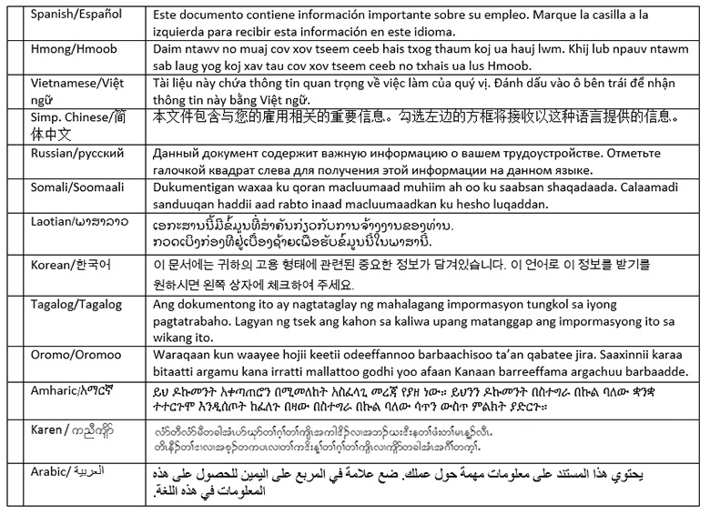

Translation providers approved by the Minnesota Department of Administration
Betmar Languages, Inc.  6260 Hwy. 65 N.E.  Minneapolis, MN 55432  763-572-9711  best@betmar.com | The Bridge World Language Center, Inc.  110 Second Street S., #308  Waite Park, MN 56387  320-259-9239  mini@bridgelanguage.com | Fox Translation Services  1152 Mae Street, #122  Hummelstown, PA 17033  866-369-1646 or 407-733-3720  dina@foxfoxcasemanagement.com
Global Translation and Interpreter  913 E. Franklin Ave., #206  Minneapolis, MN 55404  612-722-1244  sandor@globaltranslations.com | Latin American Translators Network, Inc.  1720 Peachtree Street N.W., #532  Atlanta, GA 30309  800-943-5286, ext. 8641, translations@latn.com  800-943-5286, ext. 8620, idenis@latn.com | Latitude Prime, LLC  80 S. Eighth Street, #900  Minneapolis, MN 55402  888-341-9080, ext. 501  elle@latitude.com
Lingualinx Language Solutions, Inc.  433 River Street, #6001  Troy, NY 12180  518-388-9000  abartlett@lingualinx.com | Prisma International, Inc.  1128 Harmon Place, #310  Minneapolis, MN 55403  612-349-3111  jromano@prisma.com | Swits, LTD  110 S. Third Street  Delavan, WI 53115  262-740-2590  translations@swits.us

