

Employee wage notice and Packinghouse Workers of Bill of Rights explanation form
Meatpacking and poultry processing employers are required to provide the information in this form to each employee at the start of their employment in the native language of the employee.
The information must be provided in writing and must also be explained verbally to each employee at the start of their employment. More information about these requirements can be found at Minnesota Statutes 179.86 and dli.mn.gov/packinghouse.
- Employee: Address:
Phone number: Email address:
Native language of employee:
Date employment began: Work hours:
Job description:
Occupational hazards known to exist on the job:
Workers’ compensation insurance carrier’s name, phone number and policy number:

- Legal name of employer: Main office/principal place of business address:

Phone number: Email address:
Operating name of employer (if different):
Mailing address (if different):
- Employment status (exempt or non-exempt):
☐ Employee is exempt from: ☐ minimum wage ☐ overtime ☐ other provisions of Minnesota Statutes 177
Legal basis for exemption:
☐ Employee is non-exempt (entitled to overtime, minimum wage, other protections under Minn. Stat. 177)
- Rate or rates of pay
Paid by: Hour ☐ Shift ☐ Day ☐ Week ☐ Salary ☐ Piece ☐ Commission ☐ Other method ☐
Overtime is owed after: hours
Allowances claimed:
$ per meal for meal allowance (max = 60% of one hour of adult minimum wage per meal)
$ per day for lodging allowance (max = 75% of one hour of adult minimum wage per day) (or fair market value)
- Leave benefits available:
☐ Sick leave ☐ Paid vacation ☐ Other paid time off
How benefits are accrued: Number of hours ________ or days ________
per ☐ year ☐ month ☐ per pay period ☐ per hours worked
Leave policies/Terms of use:
6. Deductions that may be made from employee’s pay and amounts:

7. Number of days in the pay period: Regularly scheduled payday:
Date employee will receive first payment of wages earned:
8. Other information relevant to this position:
I, the employee, have received a copy of this notice: ☐ Yes ☐ No
Employer representative’s name (print) Date Employee’s name (print) Date

Employer representative’s signature Date Employee’s signature Date

Your rights as a meatpacking or poultry processing worker
- You have the right to organize and bargain collectively. You also have the right to refrain from organizing and bargaining collectively. For more information, contact the National Labor Relations Board at 612-348-1757.
- You have the right to be safe at work. For more information, contact Minnesota OSHA Compliance at 651-284-5050 or osha.compliance@state.mn.us.
- You have the right to be free from discrimination at work based on race, color, creed, religion, national origin, sex, marital status, disability, public assistance status, age, sexual orientation, gender identity, familial status and local human rights commission activity. For more information, contact the Minnesota Department of Human Rights at 833-454-0148.
- If your employer is required to have workers’ compensation insurance, you have the right to have that insurance help cover your workplace accident or injury. For more information, contact the Office of the Workers’ Compensation Ombudsman at 651-284-5013 or dli.ombudsman@state.mn.us.
For additional questions or concerns you may have as a meatpacking or poultry processing worker in Minnesota, contact the Minnesota Department of Labor and Industry’s Labor Standards Division at 651-284-5075 or dli.laborstandards@state.mn.us.

This document contains important information about your employment. Check the box at left to receive
this information in this language.
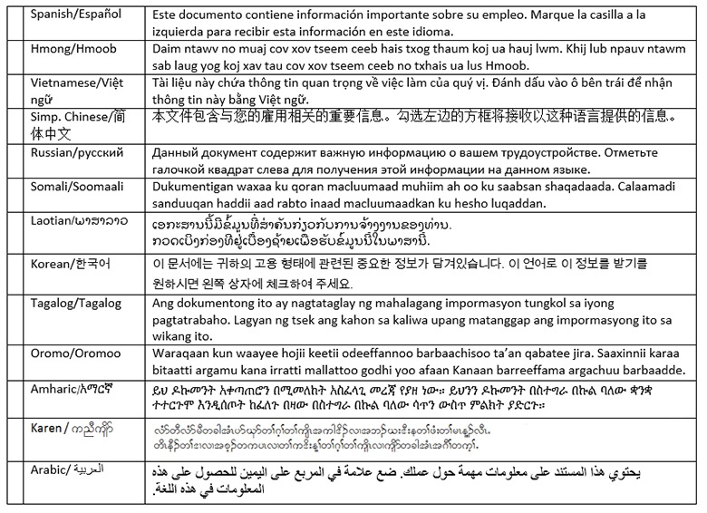

Translation providers approved by the Minnesota Department of Administration
Betmar Languages, Inc.  6260 Hwy. 65 N.E.  Minneapolis, MN 55432  763-572-9711  best@betmar.com | The Bridge World Language Center, Inc.  110 Second Street S., #308  Waite Park, MN 56387  320-259-9239  mini@bridgelanguage.com | Fox Translation Services  1152 Mae Street, #122  Hummelstown, PA 17033  866-369-1646 or 407-733-3720  dina@foxfoxcasemanagement.com
Global Translation and Interpreter  913 E. Franklin Ave., #206  Minneapolis, MN 55404  612-722-1244  sandor@globaltranslations.com | Latin American Translators Network, Inc.  1720 Peachtree Street N.W., #532  Atlanta, GA 30309  800-943-5286, ext. 8641, translations@latn.com  800-943-5286, ext. 8620, idenis@latn.com | Latitude Prime, LLC  80 S. Eighth Street, #900  Minneapolis, MN 55402  888-341-9080, ext. 501  elle@latitude.com
Lingualinx Language Solutions, Inc.  433 River Street, #6001  Troy, NY 12180  518-388-9000  abartlett@lingualinx.com | Prisma International, Inc.  1128 Harmon Place, #310  Minneapolis, MN 55403  612-349-3111  jromano@prisma.com | Swits, LTD  110 S. Third Street  Delavan, WI 53115  262-740-2590  translations@swits.us

