

Ogeysiiska Mushaharka Shaqaalaha iyo Foomka Sharaxaadda Xuquuqda Shaqaalaha Bakhaarka Baakadaha
Loo-shaqeeyayaasha ka shaqeeya warshadaha baakadaynta hilibka iyo farsamaynta digaagga waxaa looga baahan yahay inay siiyaan shaqaalaha macluumaadka ku jira foomkan marka ay shaqada bilaabayaan, iyadoo lagu bixinayo luqadda hooyo ee shaqaalaha.
Macluumaadkan waa in lagu bixiyo qoraal ahaan isla markaana si af ah loogu sharaxo shaqaalaha marka ay shaqada bilaabayaan.
Macluumaad dheeraad ah oo ku saabsan shuruudahan waxaa laga heli karaa Xeerarka Minnesota Statutes 179.86 i
iyo dli.mn.gov/packinghouse.

1.Shaqaalaha: | Cinwaanka:
Lambarka taleefoonka: | Cinwaanka iimaylka:
Luuqadda hooyo ee shaqaalaha:
Taariikhda shaqada la bilaabay: | Saacadaha shaqada:
Sharaxaadda shaqada:
Khatarta shaqo ee la og yahay inay jirto:
Magaca shirkadda caymiska magdhowga shaqaalaha, lambarka taleefoonka iyo lambarka siyaasadda:
:
2. Magaca sharciga ah ee loo-shaqeeyaha: | Cinwaanka xafiiska ugu weyn/goobta ganacsiga ugu weyn:
Lambarka taleefanka: | Cinwaanka iimaylka:
Magaca loo-shaqeeyaha ee lagu shaqeeyo (haddii uu ka duwan yahay):
Cinwaanka boostada (haddii uu ka duwan yahay):
Xaaladda shaqada (xor ka ah sharciyada ama aan xor ka ahayn):
- Shaqaaluhu way ka xorran yahiin: ☐ Mushaarka ugu yar ☐ Saacadaha dheeraadka ah☐ Qodobo kale oo ka mid ah Xeerka
Minnesota 177 provisions of Minnesota Statutes 177
Legal basis for exemption:
- Shaqaaluhu ma aha mid ka xorran (wuxuu xaq u leeyahay saacadaha dheeraadka ah, mushaarka ugu yar, iyo ilaalinta kale ee Minn. Stat. 177))
4. Heerka ama heerarka mushaarka:
Loo bixiyaa:Saacad☐ Shift ☐ Maalin☐ Isbuuc ☐ Mushaar ☐ Qayb-gaar ah ☐ Komishan ☐Hab kale ☐
Lacagta saacadaha dheeraadka ah la bixinayo kadib: | Saacadood
Gunnooyinka la sheeganayo:
$ hal cunno guno ah (ugu badnaan = 60% hal saac oo mushaarka ugu yar ee qof weyn)
$ maalin walba guno hoy ah (ugu badnaan = 75% hal saac oo mushaharka ugu yar ee qof weyn maalintii) (ama qiimaha suuqa ee saxda ah)
5. Faa’iidooyinka fasaxa la heli karo:
- Fasax xanuun ☐ Fasax mushaar leh ☐ Fasax kale oo la bixiyo
Sida faa’iidooyinka loo ururiyo: Tirada saacadaha or days per ☐ year
- bishii ☐ Bishiiba marka la bixiyo ☐ saacadaha la shaqeeyay

Siyaasadaha fasaxa / Shuruudaha isticmaalka:
6. Lacagaha laga jari karo mushaarka shaqaalaha iyo qadarkooda:
7. Tirada maalmaha ku jira muddada mushaar-bixinta: Maalinta joogtada ah ee mushaar la bixiyo:
Taariikhda uu shaqaaluhu heli doono mushaharkiisa ugu horreeya ee uu kasbaday:
8. Macluumaad kale oo khuseeya jagadan:
Aniga, shaqaalaha, waxaan helay nuqul ka mid ah ogeysiiskan:: ☐ Haa ☐ Maya
Magaca wakiilka loo-shaqeeyaha (daabacan): Taariikhda Magaca shaqaalaha (daabacan):) Taariikhda
Saxiixa wakiilka loo-shaqeeyaha: Taariikhda Saxiixa shaqaalaha: Taariikhda

Xuquuqdaada Shaqo ahaan Haddii Aad Tahay Shaqaale Ka Shaqeeya Warshadaha Hilibka Ama Ka Baaraandega Digaagga
- Waxaad xaq u leedahay inaad isu abaabusho oo aad si wadajir ah u gorgortanto. Waxaad sidoo kale xaq u leedahay inaadan isu abaabulin ama gorgortan wadajir ah sameyn. Wixii macluumaad dheeraad ah, kala xiriir Guddiga Xiriirka Shaqaalaha Qaranka ee 612-348-1757.
- Waxaad xaq u leedahay inaad badbaado ku ahaato goobtaada shaqada. Wixii macluumaad dheeraad ah, la xiriir
Waaxda U Hoggaansanaanta Amniga iyo Caafimaadka Shaqaalaha ee Minnesota ee 651-284-5050 ama osha.compliance@state.mn.us.
- Waxaad xaq u leedahay in lagaa ilaaliyo takoorka shaqada. Shaqo lagaama reebi karo mana lagugu takoori karo
sabab la xiriirta jinsiyad, midab, caqiido, diin, asal qaran, jinsi, xaaladda guurka, naafonimo, xaaladda caawimada dadweynaha, da’, jihaynta galmada, aqoonsiga jinsiga, xaaladda qoyska ama ka-qaybgalka howlaha guddiyada xuquuqda aadanaha ee deegaanka. Wixii macluumaad dheeraad ah, kala xiriir Waaxda Xuquuqda Aadanaha ee Minnesota ee 833-454-0148.
- Haddii loo-shaqeeyahaagu uu sharcigu ka rabo inuu yeesho caymiska magdhowga shaqaalaha, waxaad xaq u
leedahay in caymiskaasi daboolo dhaawac ama shil shaqo oo kugu dhaca. Wixii macluumaad dheeraad ah, kala xiriir Xafiiska Difaacaha Magdhowga Shaqaalaha ee 651-284-5013 ama dli.ombudsman@state.mn.us.

Haddii aad qabto su’aalo dheeraad ah ama walaacyo la xiriira shaqadaada warshadaha hilibka ama ka baaraandega digaagga ee Minnesota, kala xiriir Waaxda Heerarka Shaqada ee Waaxda Shaqada iyo Warshadaha ee Minnesota (Minnesota Department of Labor and Industry’s Labor Standards Division) lambarka ee 651-284-5075 ama dli.laborstandards@state.mn.us.

Dukumentigan wuxuu ka kooban yahay macluumaad muhiim ah oo ku saabsan shaqadaada. Sax sanduuqa dhanka bidix si aad u hesho macluumaadkan oo ku qoran luqadan.
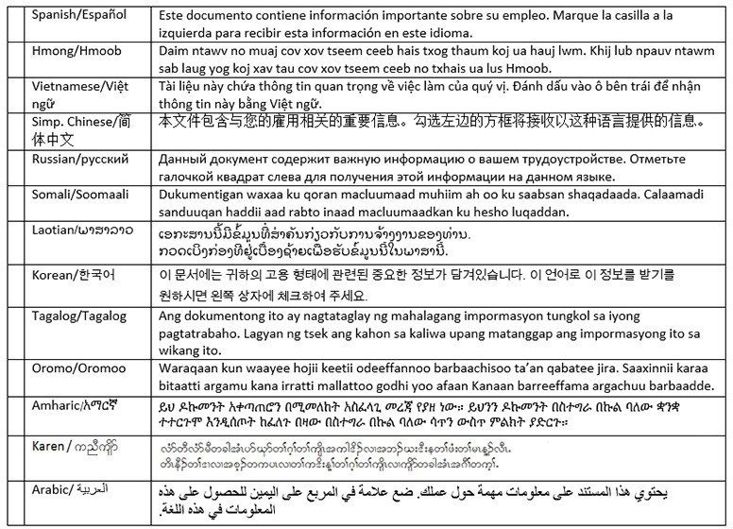

Bixiyeyaasha turjumaadda ee ay oggolaatay Waaxda Maamulka ee Minnesota

Betmar Languages, Inc. | The Bridge World Language Center, Inc. | Fox Translation Services
6260 Hwy. 65 N.E. | 110 Second Street S., #308 | 1152 Mae Street, #122
Minneapolis, MN 55432 | Waite Park, MN 56387 | Hummelstown, PA 17033
763-572-9711 | 320-259-9239 | 866-369-1646 or 407-733-3720
best@betmar.com | mini@bridgelanguage.com | dina@foxfoxcasemanagement.com
Global Translation and | Latin American Translators Network, Inc. | Latitude Prime, LLC
Interpreter | 1720 Peachtree Street N.W., #532 | 80 S. Eighth Street, #900
913 E. Franklin Ave., #206 | Atlanta, GA 30309 | Minneapolis, MN 55402
Minneapolis, MN 55404 | 800-943-5286, ext. 8641, translations@latn.com | 888-341-9080, ext. 501
612-722-1244 | 800-943-5286, ext. 8620, idenis@latn.com | elle@latitude.com
sandor@globaltranslations.com
Lingualinx Language Solutions, | Prisma International, Inc. | Swits, LTD
Inc. | 1128 Harmon Place, #310 | 110 S. Third Street
433 River Street, #6001 | Minneapolis, MN 55403 | Delavan, WI 53115
Troy, NY 12180 | 612-349-3111 | 262-740-2590
518-388-9000 | jromano@prisma.com | translations@swits.us
abartlett@lingualinx.com

